**UNIVERSITI MALAYSIA TERENGGANU**

**BACHELOR OF COMPUTER SCIENCE (MOBILE COMPUTING)**

**WITH HONOURS**

**SEM 2 2022 / 2023**

**CSM 3103: FRONT-END PROGRAMMING (K2)**

**LAB REPORT 3**

**PREPARED BY:**

MUHAMMAD NAJMUDDIN BIN AZLI (S62728)

**LECTURER:**

DR RABIEI BIN MAMAT

Task 1

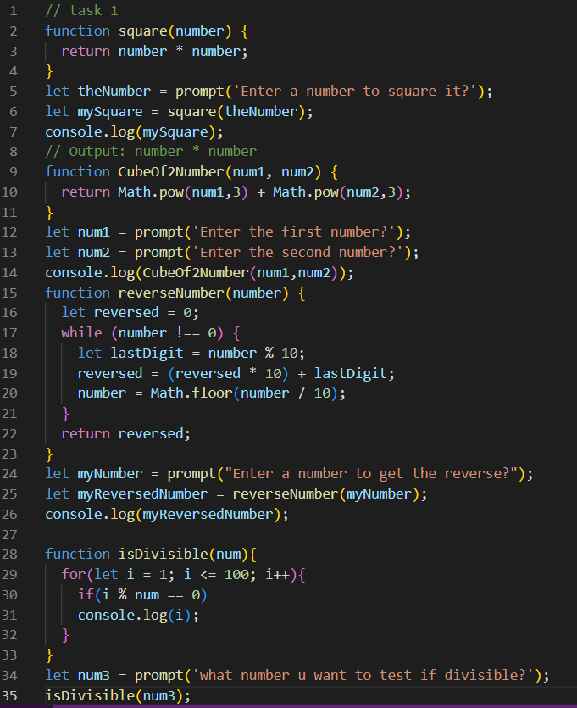

Task 2

Task 3

Task 5

Task 6

